Showing Young Children How to Cook

With cooking being both an art and science, we at Pre-School believe it can be a great opportunity to learn lots of new skills. We have always made cooking part of our curriculum and would love to see how the children are using these skills at home. After the success of our Scottish themed cookery last week, we thought we would share our ever so easy recipe for shortbread biscuits and would love to see you all try this for yourselves, with your little ones, at home.

If you wish to share your child's experience, please bring in photos of your biscuits and show us how they turned out, or send them digitally via email to: www.farnsfieldpreschool.org
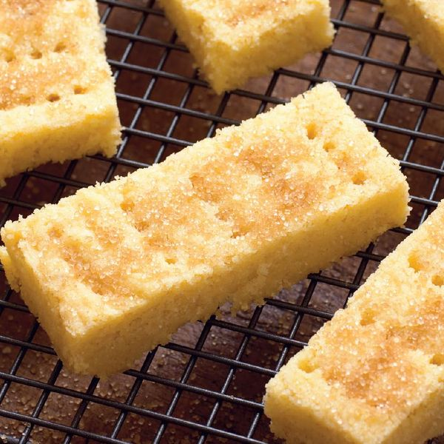

Shortbread Biscuits: A Recipe for Fun

Ingredients

225g (8oz) plain flour | 100g (4oz) semolina | 225g (8oz) butter | 100g (4oz) caster sugar | 25g (1oz) demerara sugar,for dusting

Essential kit: You will need a 30 x 23cm (12 x 9in) roasting tin.

Instructions Preheat the oven to 160°C/Fan 140°C/gas 3.

Lightly grease the roasting tin.

Mix together the flour and semolina in a bowl or food processor. Add the butter and sugar and rub together with your fingertips until the mixture is just beginning to bind together. Knead lightly until the mixture forms a smooth dough.
Press the dough into the prepared tin and level it with the back of a spatula or a palette knife, making sure the mixture is evenly spread. Prick all over with a fork and chill until firm.
Bake for about 35 minutes or until a very pale golden brown. Sprinkle with demerara sugar and leave to cool in the tin for a few minutes, then cut into 30 fingers. Carefully lift the fingers out of the tin with a palette knife and finish cooling on a wire rack. Store in an airtight tin/container.

