Uniform Order
Uniform is not compulsory – it just looks nice and saves your
child’s best clothes!

Name of Child: ...............................................................................................
I would like to order the following items:
Size Quantity Price Total
Sweatshirts 2-3 yrs ............. £8.99 £.................
3-4 yrs ............. £8.99 £.................
4-5 yrs ............. £8.99 £.................

Polo Shirts 2-3 yrs ............. £7.50 £.................
3-4 yrs ............. £7.50 £.................
4-5 yrs ............. £7.50 £.................
.
Total Order £ .....................

I enclose payment of £ ….................... Signed .............................................
Cash / Cheque (Payable to Farnsfield Pre-School) / Bank transfer (09-01-53 48113285)
*Delete as appropriate
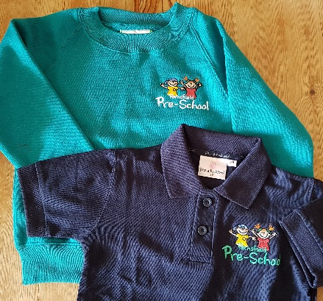
All items received (date) ………………..

Signed ……………………...…………

We have various sizes in stock if you would like to try for correct sizing.
Any queries, please speak to a member of Staff.

